**Swagger Guide**

**Purpose of This Document:**

This document explains the What is swagger, Why do we need swagger, Steps to add Swagger to the Project.

**What is Swagger:**

Swagger is a set of open-source tools built around the OpenAPI Specification that can help us design, build, document and consume REST APIs. The major Swagger tools include:

* [Swagger Editor](http://editor.swagger.io/) – browser-based editor where you can write OpenAPI specs.
* [Swagger UI](https://swagger.io/swagger-ui/) – renders OpenAPI specs as interactive API documentation.

**Why do we need Swagger:**

An Swagger file allows us to describe our entire API, including:

* Available endpoints (/users) and operations on each endpoint (GET /users, POST /users)
* Operation parameters Input and output for each operation
* Authentication methods
* Contact information, license, terms of use and other information.

**Steps to add Swagger :**

1: add swagger dependencies to the pom.xml  
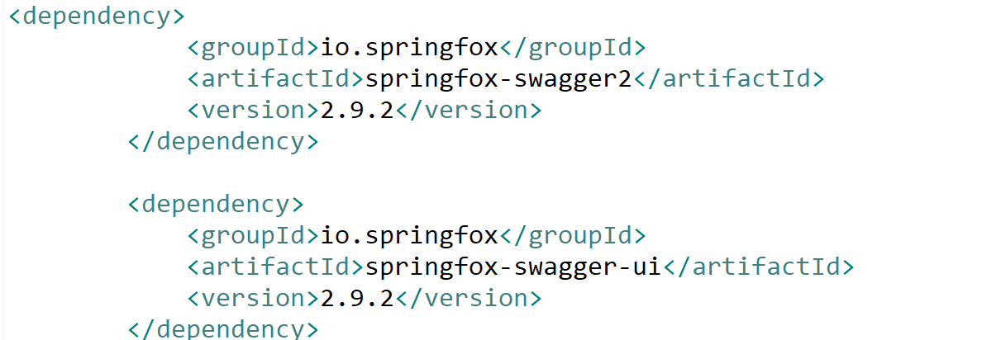

2.Create a class with the name SwaggerConfig in the configuration package

🡪This class contains the logic for swagger implementation

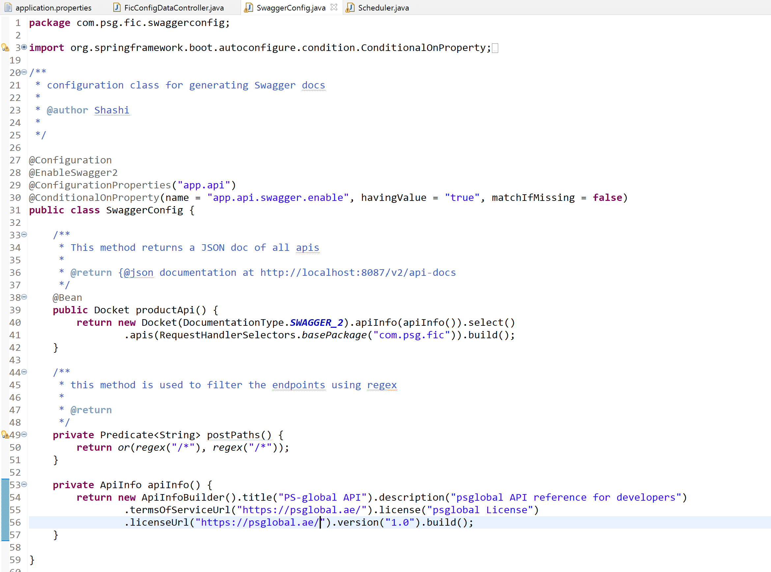

3.add a swagger config to application.properties ,this allows us to disable and enable the swagger

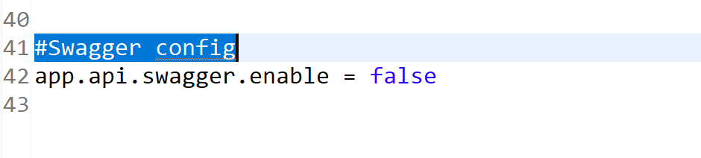

4.Run the project with following instructions.

Right click on project folder ---> select spring main class ----> select run as Java application.

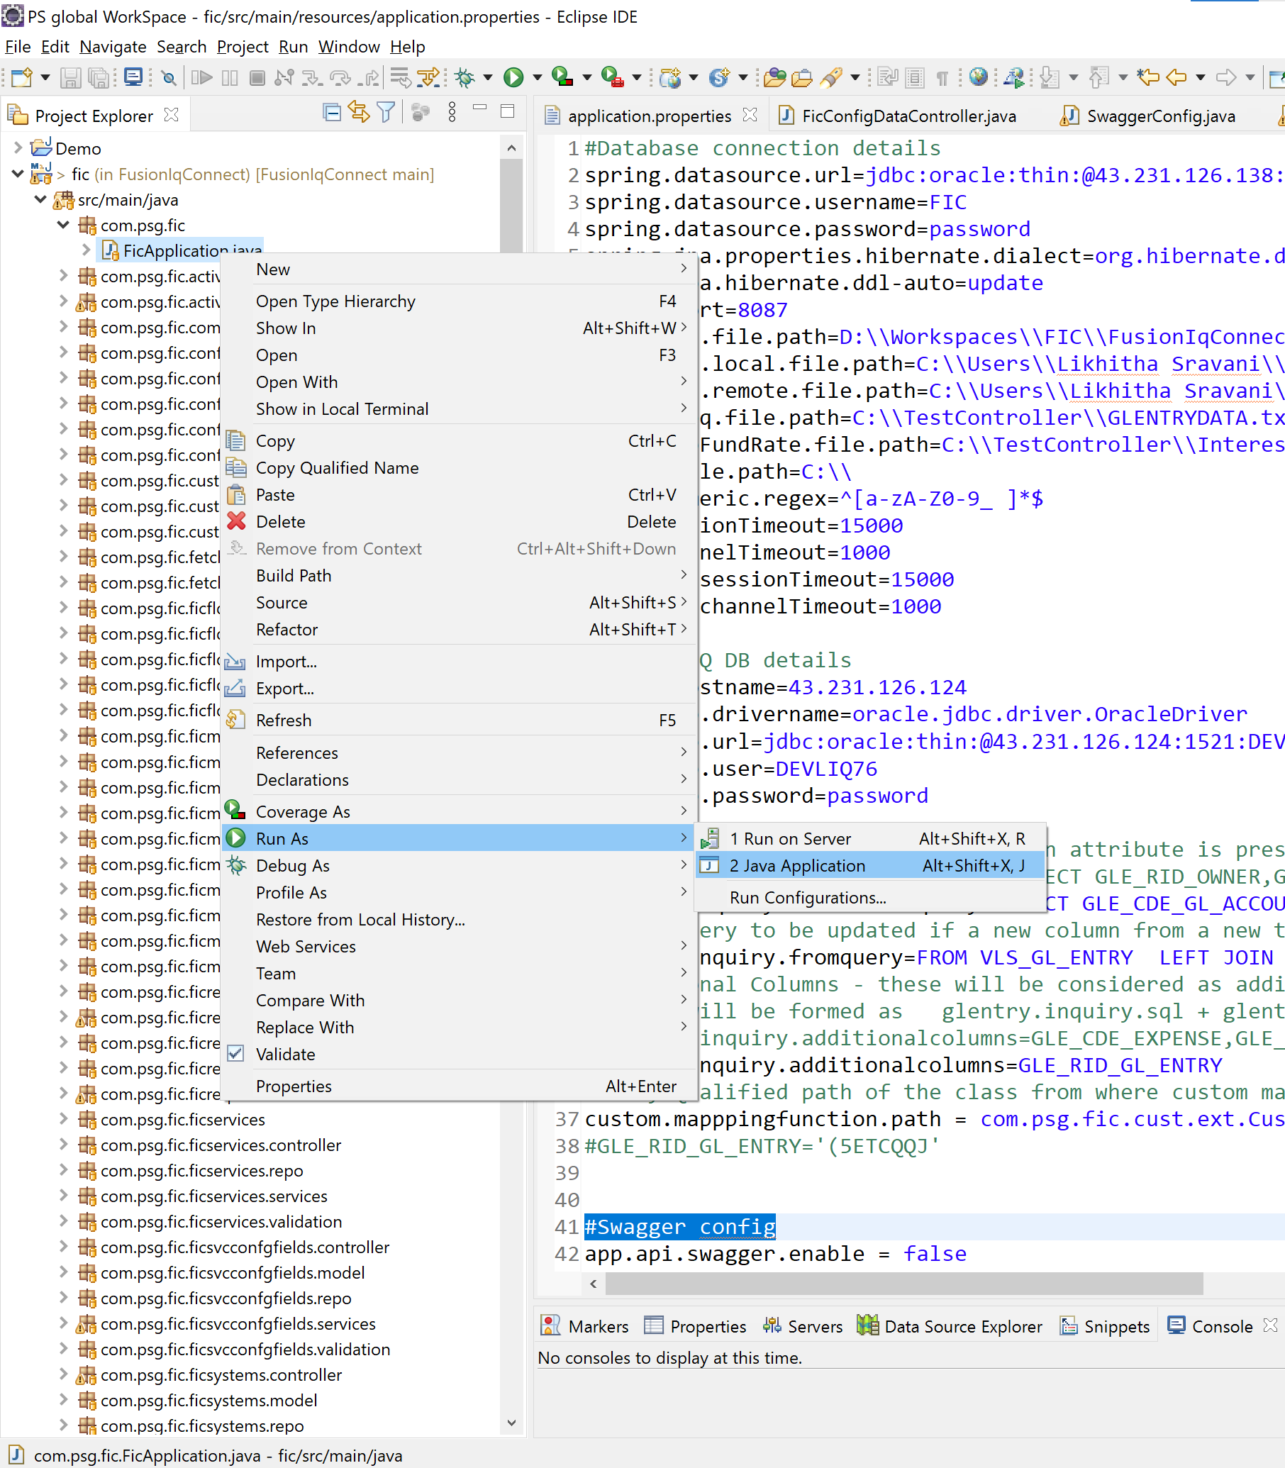

5.URL To view swagger UI

* [**http://IP:PORT/swagger-ui.html#/**](http://IP:PORT/swagger-ui.html#/)

🡪we can see all the endpoints here along with the controller name

🡪for each endpoint the type of parameters ,type of request they accept ,and response type it produces can be seen.

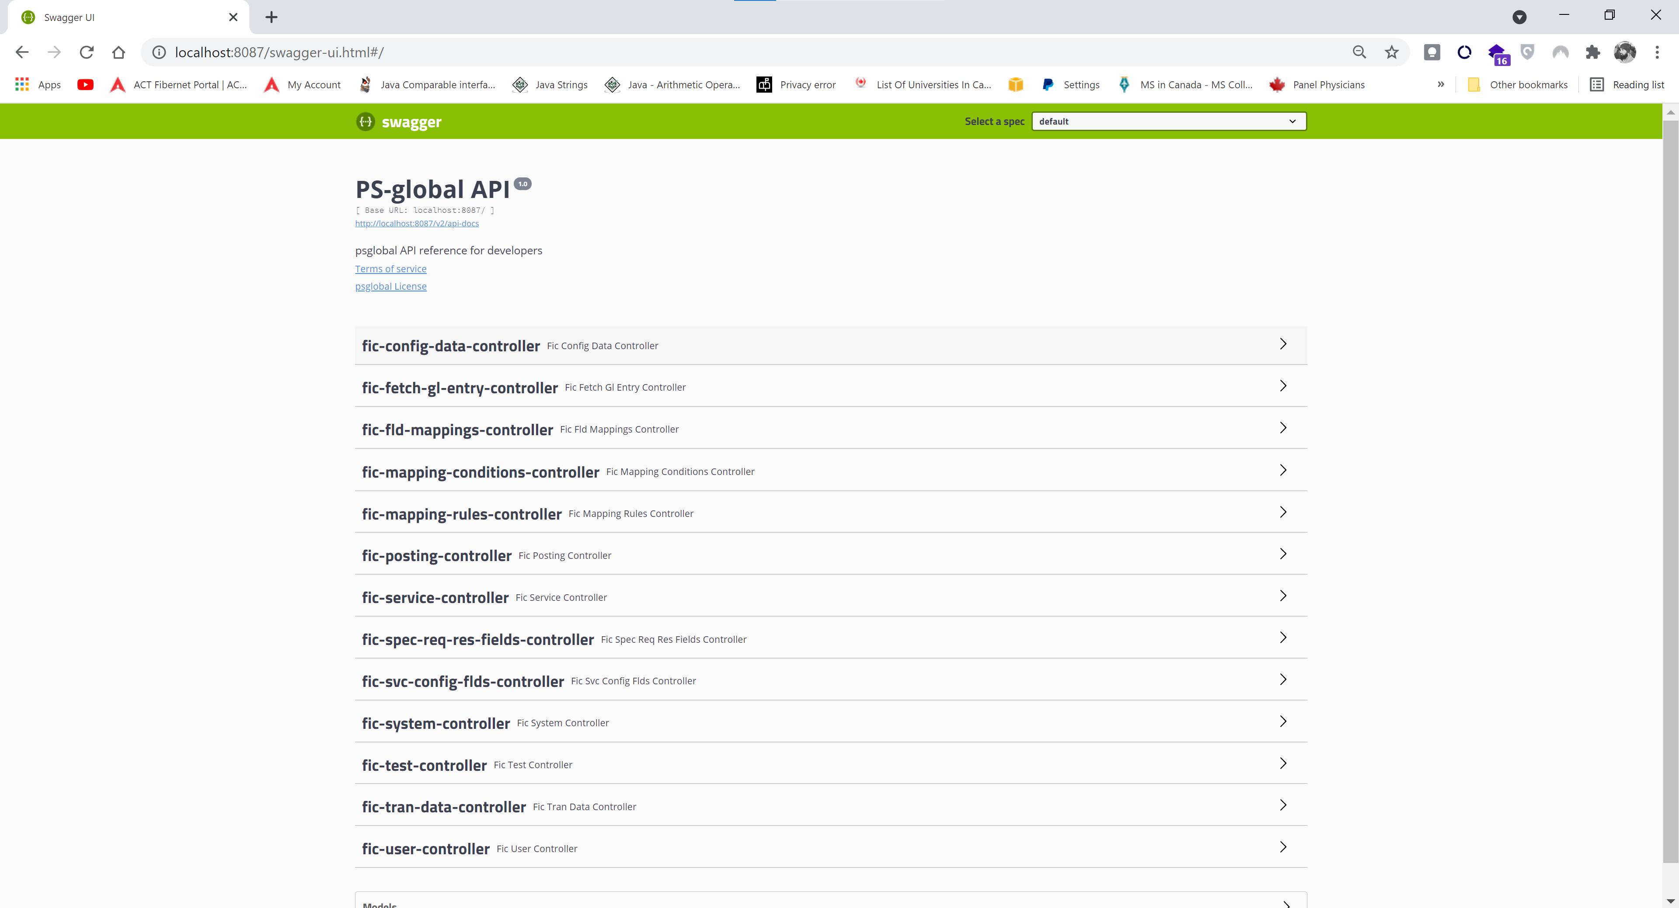

6.URL to get swagger documentation in JSON Format

* [**http://IP:PORT/v2/api-docs**](http://IP:PORT/v2/api-docs)

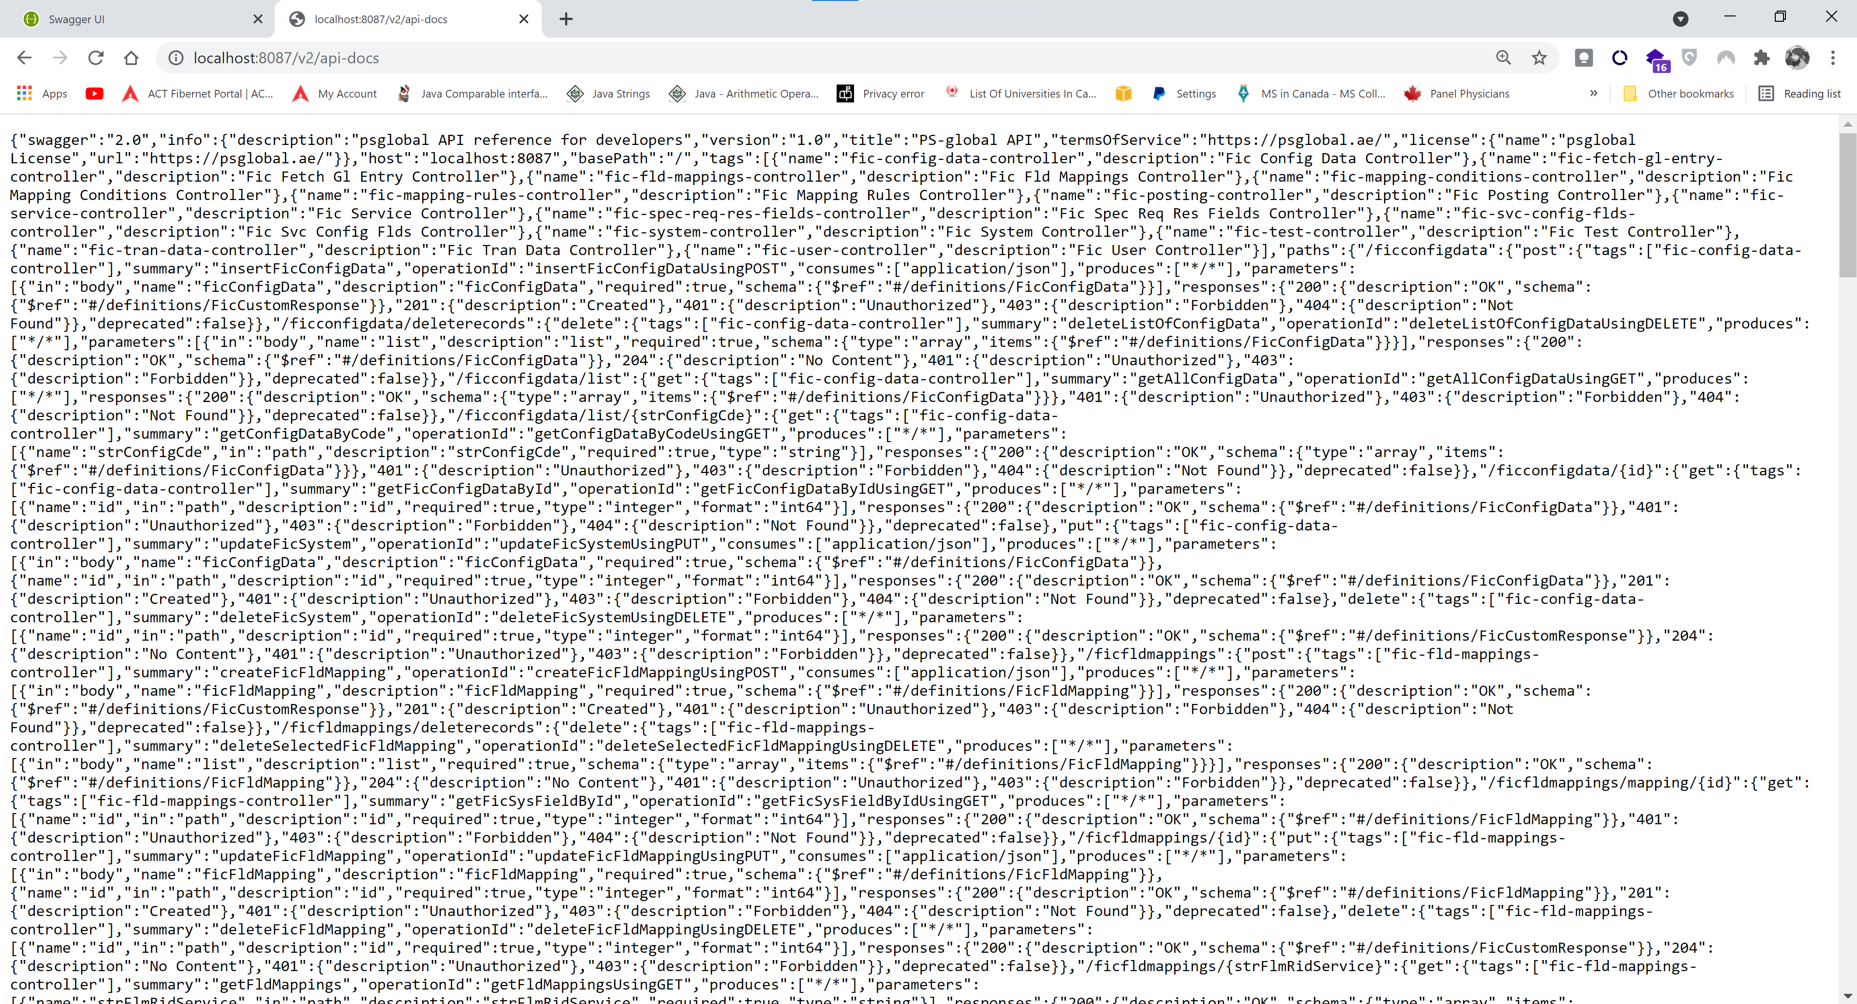

🡪This JSON document can be formatted as per our requirements and can be given to client.  
  
🡪 client can view this document in [**https://editor.swagger.io/#**](https://editor.swagger.io/#)

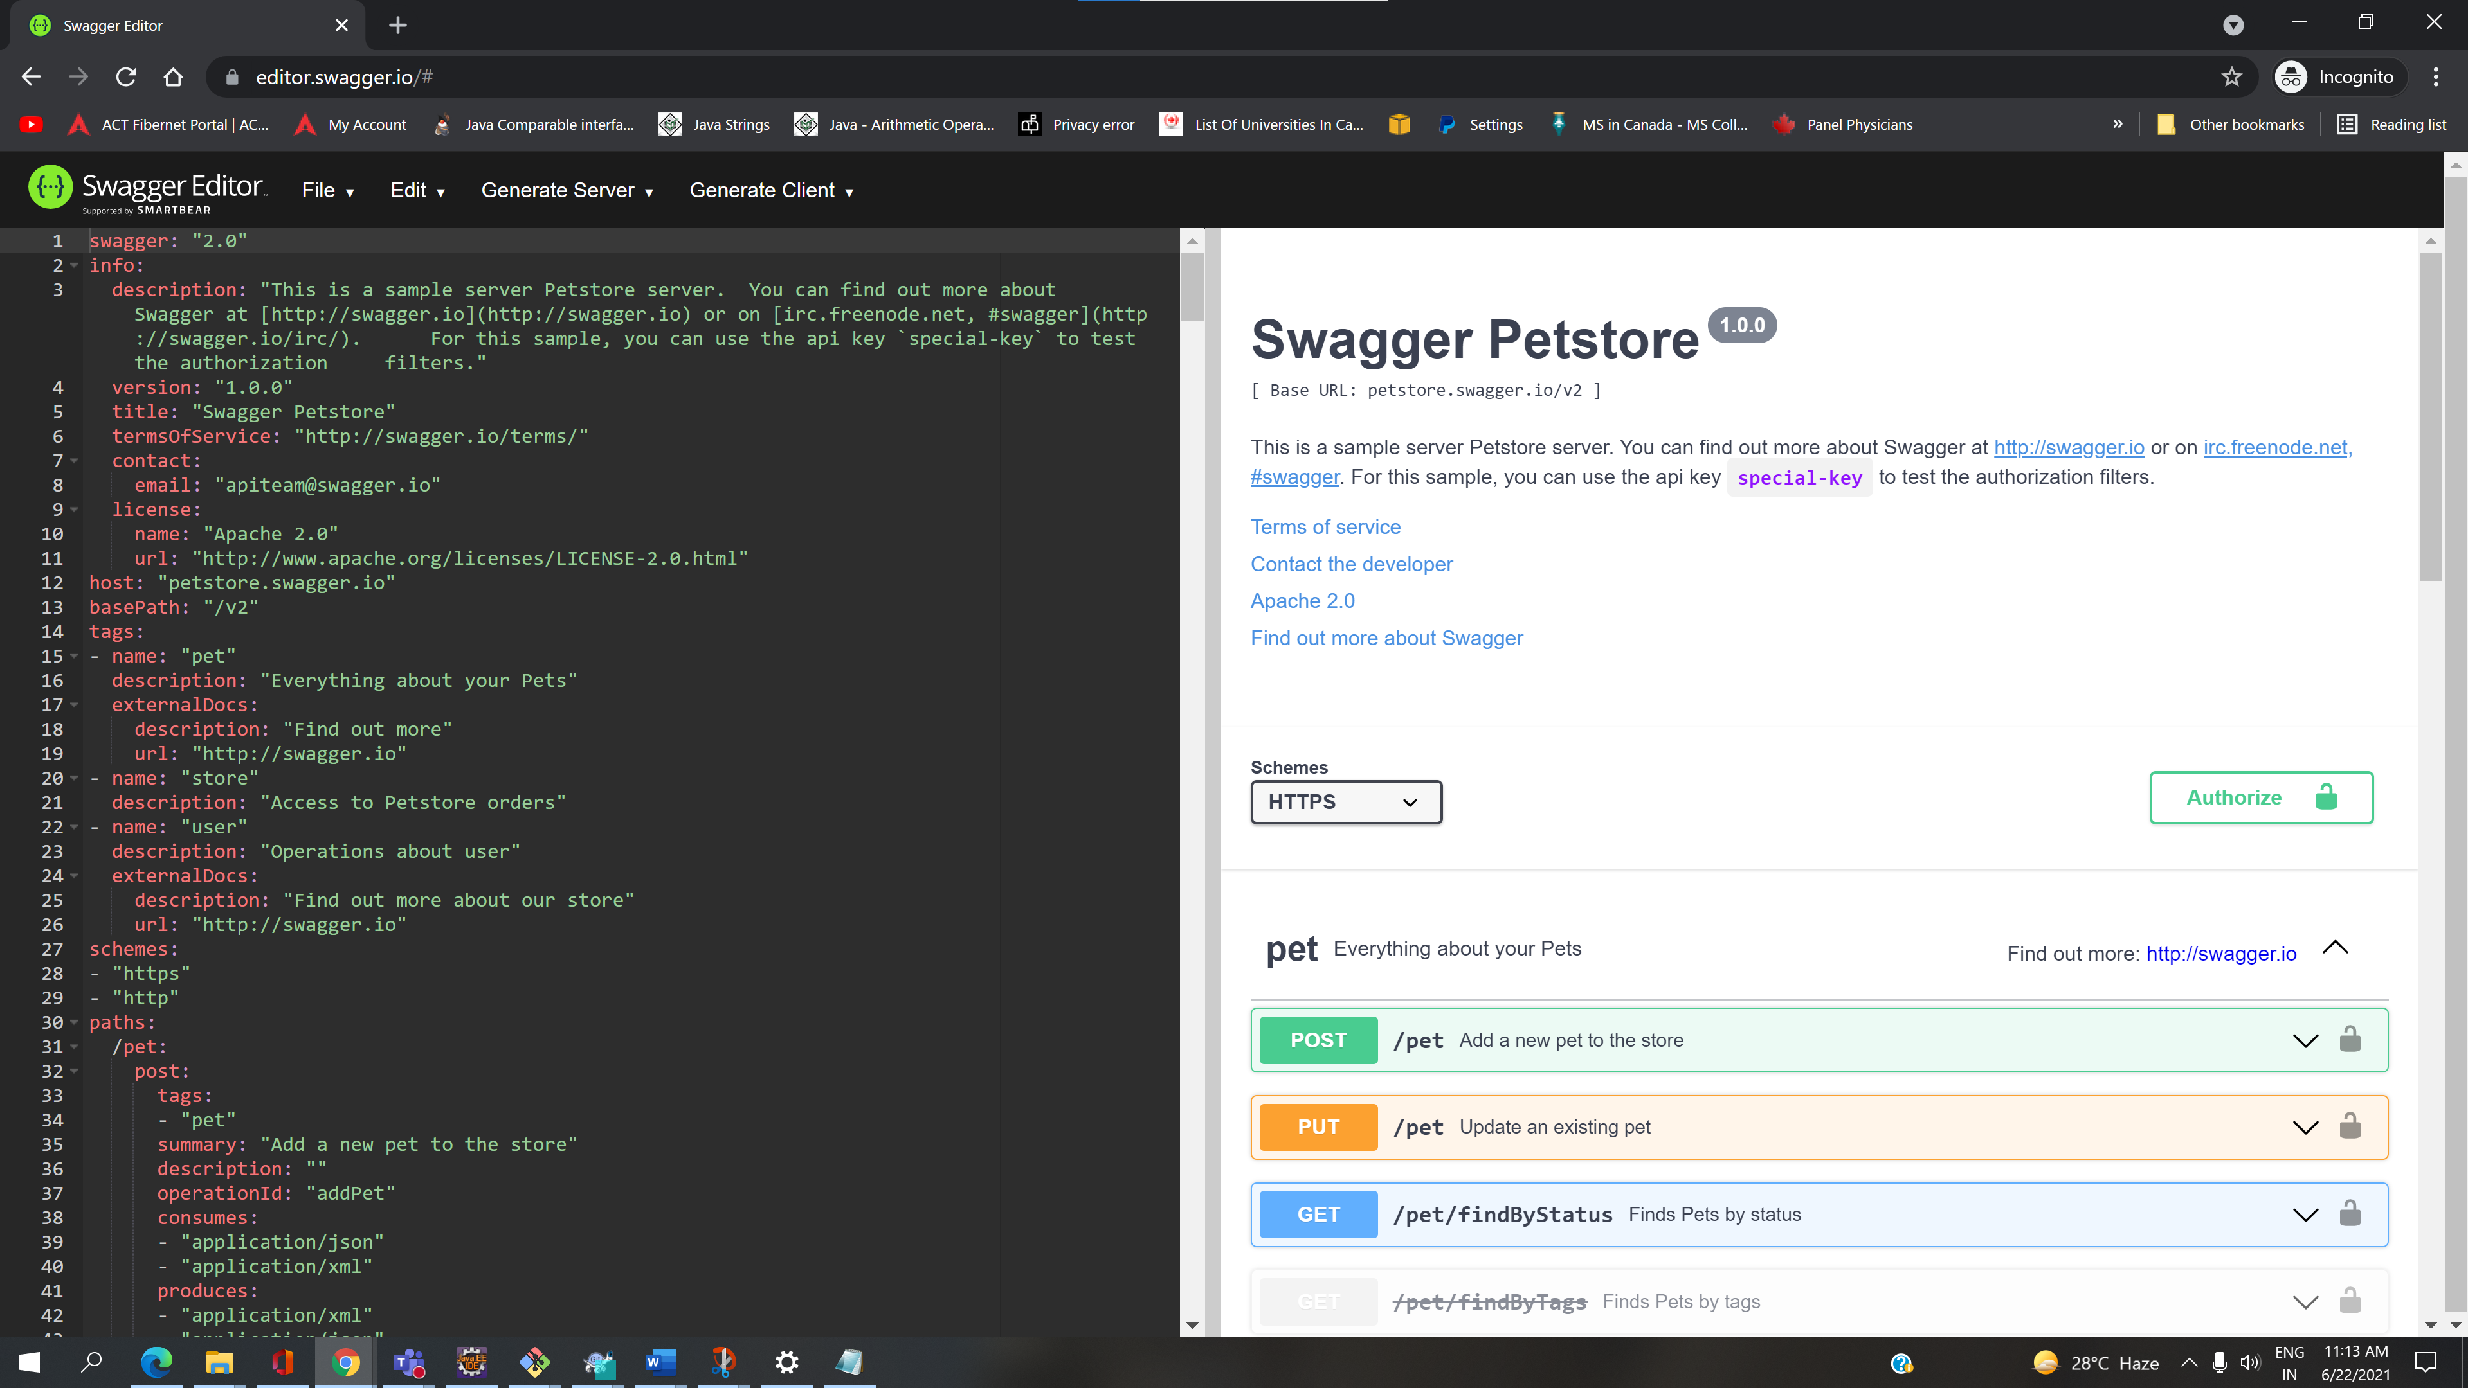

🡪Command to disable swagger in production

**java -jar fic-0.0.1-SNAPSHOT.jar --app.api.swagger.enable=false**

🡪Command to enable swagger in production

java -jar fic-0.0.1-SNAPSHOT.jar **--app.api.swagger.enable=true**

🡪annotation to ignore end points at class level or method level

Is @ApiIgnore

